Lab 5

NIS Server and Client

# Outcomes

* Be able to set up an example authentication and authorization network server, NIS.
* Make sure a client can connect to the server.

Rubric (10 points total):

Each of these items requires a checkoff from the TA. Unlike most other labs, there is no electronic submission of this lab; only checkoffs from the TA.

* NIS server working via `ypcat passwd` on server. (5 points)
* NIS client working via `ypcat passwd` on client. (5 points)

# Procedure

NIS (Network Information Service) is a simple to set authentication and authorization service for Linux. The lab covers a setup which would not be used in a production environment, but which does provide a simple example of a network authentication service.

There are some GUI tools to do most of the steps listed below, but I think you will have a better understanding of what is going on if you do the work by hand.

## Install

ypserv

ypbind

authconfig

**Note**: yp-tools rpcbind will be installed as dependencies

## Using the IP Utility

In order to find the ip address of a machine you can use the ip addr command which will print ip information associated with your host like the following

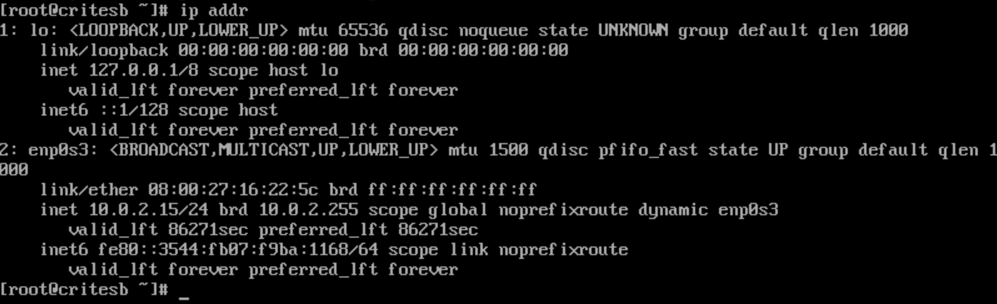

The above output shows us two network interfaces: “lo” which is the internal loopback interface (commonly known as localhost) and “enp0s3” which is an ethernet port (or virtual ethernet in this case, please note the name of your ethernet may vary slightly). Because we want to use the actual network interface we will need to use the ip address of the ethernet port which is 10.0.2.15 (as designated after “inet”)

## Add information to config files

Add NISDOMAIN=<domain-name> to /etc/sysconfig/network

This will tell your computer what your NIS domain name is. The domain name that you use to replace <domain-name> can be anything you want.

Add USENIS=yes to /etc/sysconfig/authconfig

Your computer needs to know to use NIS for auth

Add domain <domain-name> server 127.0.0.1 to /etc/yp.conf

Add nis to the passwd line in /etc/nsswitch.conf before the file keyword

Add nis to the shadow line in /etc/nsswitch.conf before the file keyword

Add nis to the group line in /etc/nsswitch.conf before the file keyword

Add nis to the hosts line in /etc/nsswitch.conf before the file keyword

Add 127.0.0.1 <server-host-name> to /etc/hosts

## Set up PAM to use NIS

authconfig --update --nisdomain=<domain-name> --nisserver=<server-host-name> --enablenis

## Start Services with Systemctl

User systemctl to start each of the following services:

rpcbind

ypserv

yppasswdd

initialize you NIS master database

/usr/lib64/yp/ypinit –m

Start ypbind service

## Set each Service to Autostart with Systemctl

Use systemctl to have each of the following services autostart:

ypserv

ypbind

yppasswdd

rpcbind

Type ypcat passwd and you should see your local account. You can change the password by typing yppasswd <user>

### Do not ever do this on a production machine!!!!

disable firewall (firewalld):

systemctl stop firewalld

systemctl disable firewalld

You may need to do the same for iptables

## Setting up a client

The client will need to talk to your server. So set up a 'NAT Network' device in virtualbox, and make sure your existing VM is using that network.

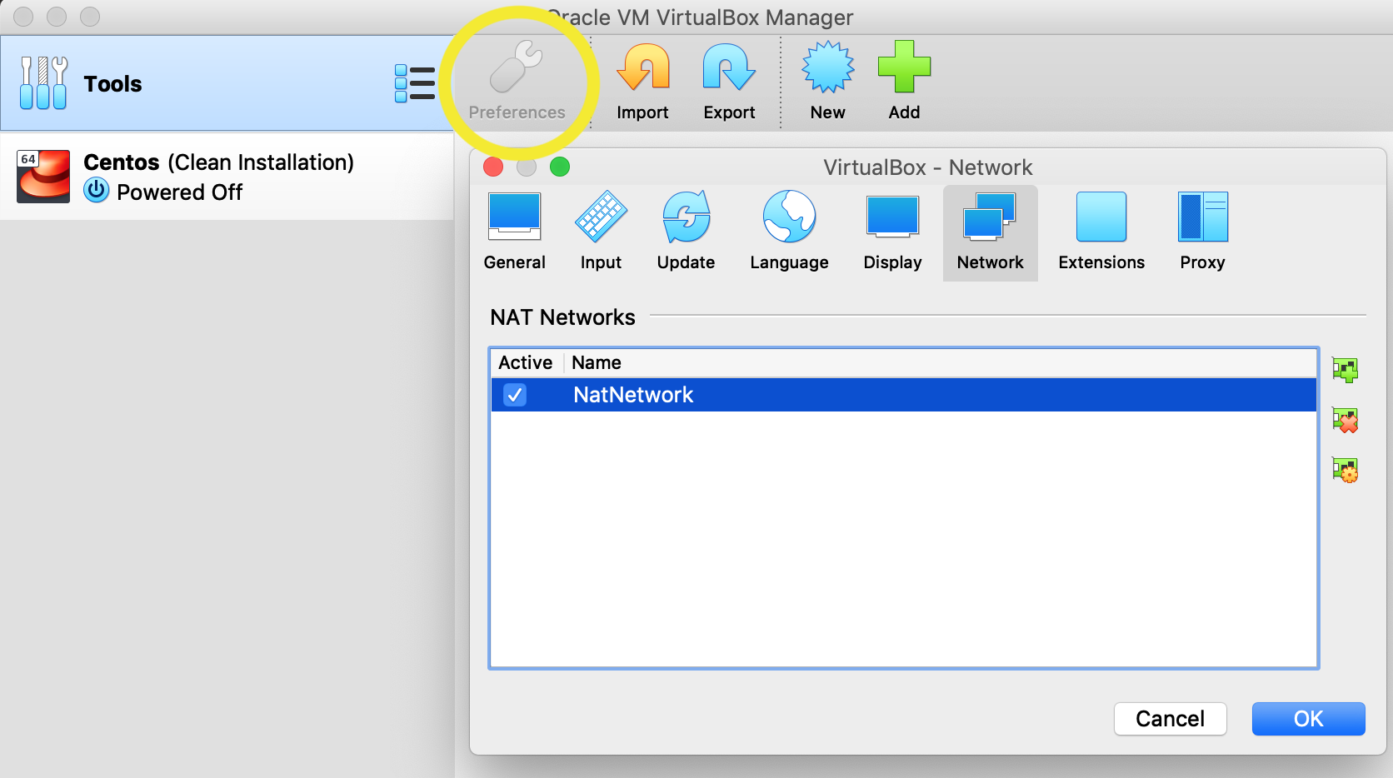

Install a new CentOS 7 virtual machine, or use the snapshot you made from lab1, using that NAT network.

Before moving on, make sure that the client can ping the server (you will need to have both your client and server VMs running for this and the following steps). If the ping is able to send and receive packets then they are able to communicate on the network, if the ping fails to send and receive packets then your network is misconfigured.

On the client, run authconfig-tui and add nis and add the server hostname and domain name from above.

Set your NIS domain name

ypdomainname <domain-name>

Add NISDOMAIN=<domain-name> to the file /etc/sysconfig/network

Add the following line to /etc/hosts, with the angle bracket variables like <server-hostname> filled in for your configuration. Please take special note that there are three fields here each separated by spaces and the middle field has a dot (.) between server-hostname and domain-name.

<server-ip-address> <server-host-name>.<domain-name> <server-host-name>

You can get the ip address for the server by running ip addr on the server

Run the following authconfig command to enable NIS on the client

authconfig --enablenis --nisdomain=<domain-name> --nisserver=<server-host-name>.<domain-name> --enablemkhomedir --update

Use systemctl to start each of the following services, then have each of them autostart

rpcbind

ypbind

To validate, run the ypwhich command and you should see the following output:

$ <server-host-name>.<domain-name>

To verify everything is working type ypcat passwd on the client and you should see your user account for the nis master.

# Submission

Demonstrate to your TA that you are able to change a user password on the NIS server and have that change reflected when logging into the NIS client.rp